Advanced Certification in Cloud Computing and

DevOps Assignment 1

**1. Setting up the Terraform:**

○ Create an Instance in AWS.

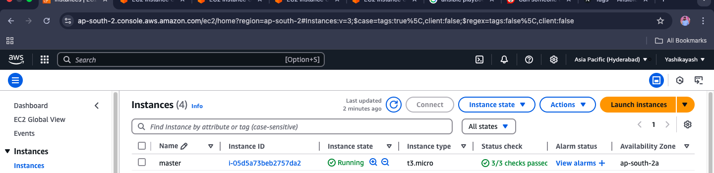

○ Install Terraform in that particular AWS Instance

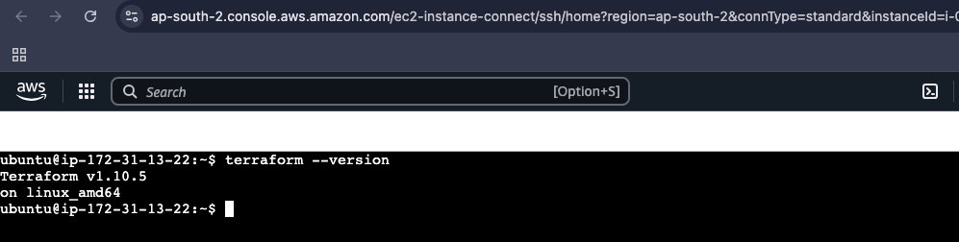

**2. Setting up the Infrastructure using Terraform:**

○ A Terraform script has to be created for creating the required Infrastructure, details on the same are mentioned in the points below.

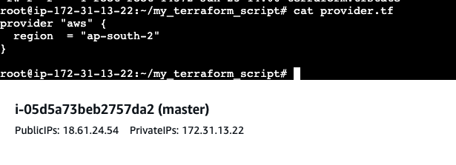

○ 3 Instances are supposed to be created via the Terraform script.

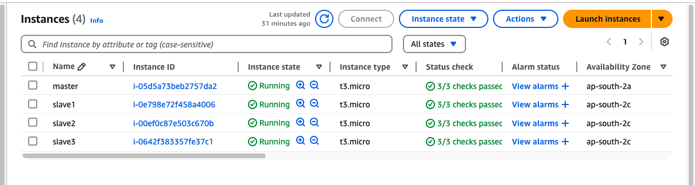

○ No VPC or Subnet or any other resources are required to be created, default Subnet can be used to create the Instances in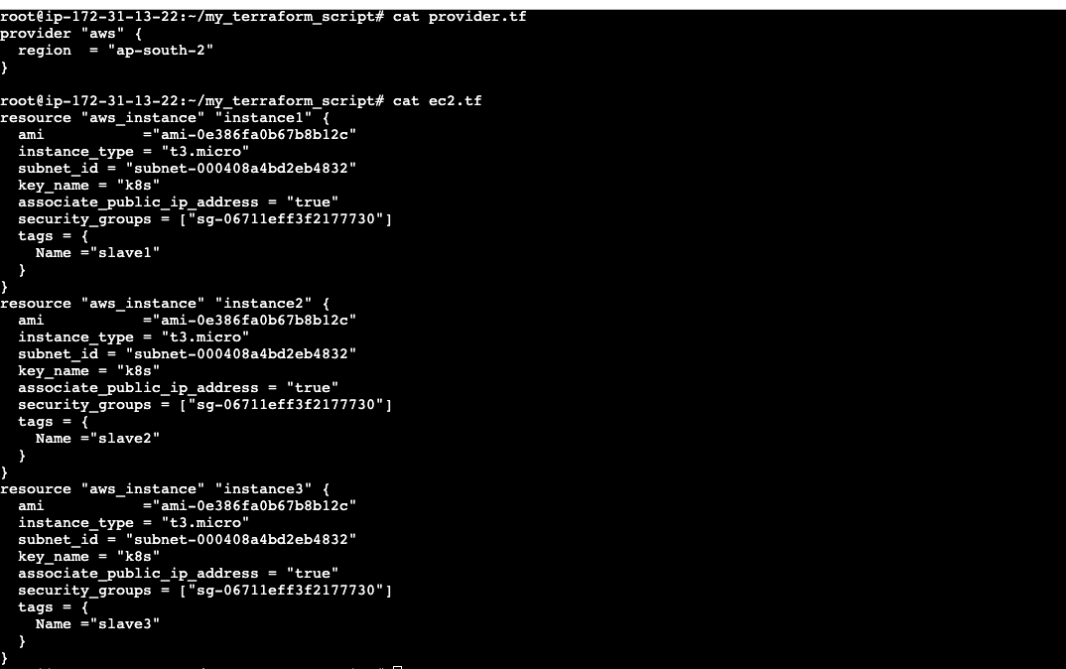

**3. Setting Ansible up:**

○ Install Ansible in the same Machine where Terraform has been installed. 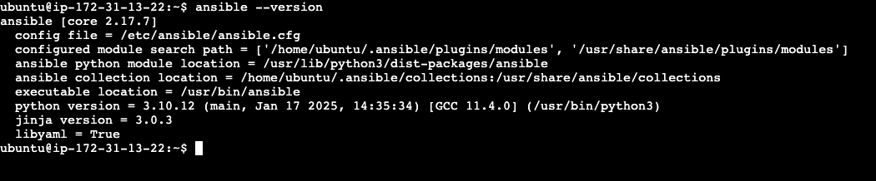

○ Setup Ansible up, i.e. create the connection between the Ansible Master and all 3 of the Slaves. 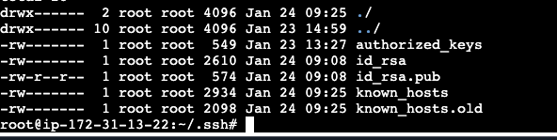

**4. Creating the Ansible playbook to set the desired configurations:**

○ 3 Roles are supposed to be created, namely “Java”, “Python” and “MySQL” which will be installing Java, Python and MySQL respectively.

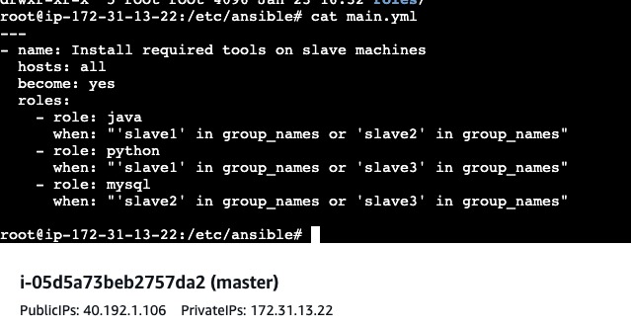

○ In Slave1 Java and Python is supposed to be installed

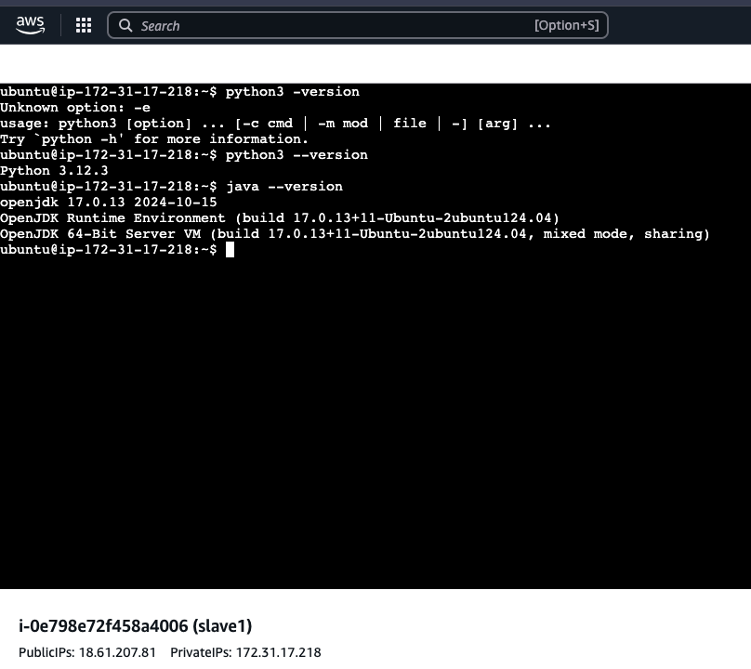

○ In Slave2 Java and MySQL is supposed to be installed

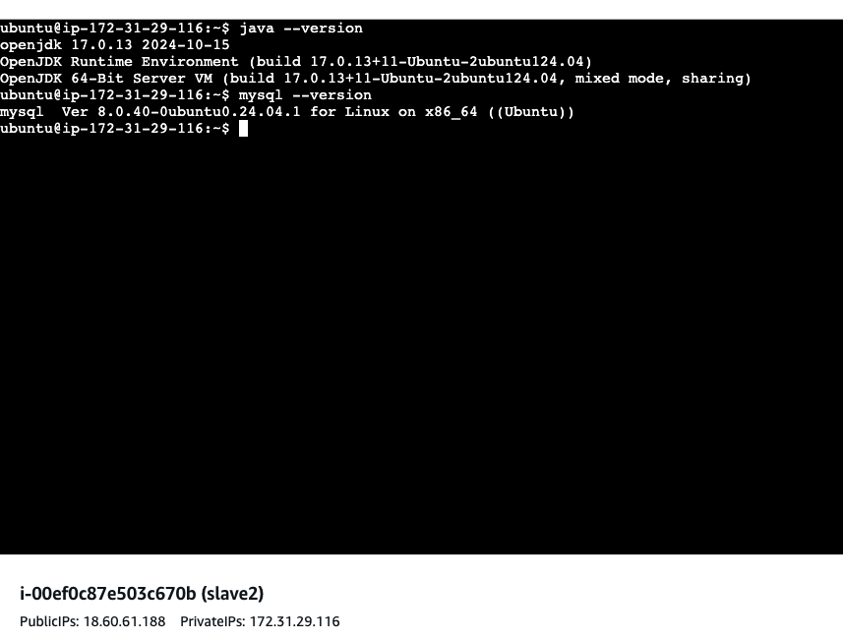

○ In Slave3 MySQL and Python is supposed to be installed

